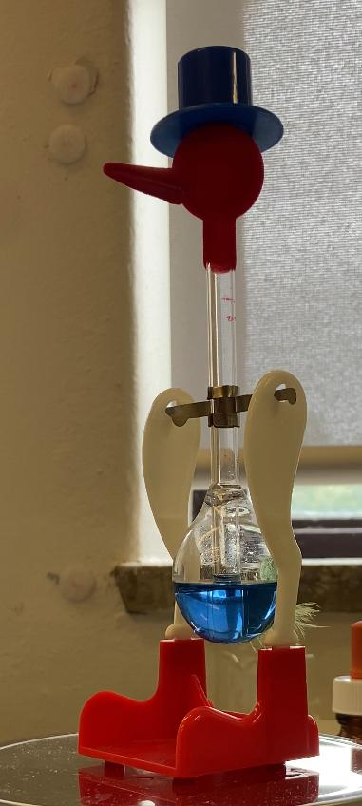

**Axel and Base (5)**

**DCM (4)**

**Bird felt head (3)**

**Glass gas spheres (1)**

**Glass cylinder (2)**